Login in to paypal.com
Click Send & Request Button.
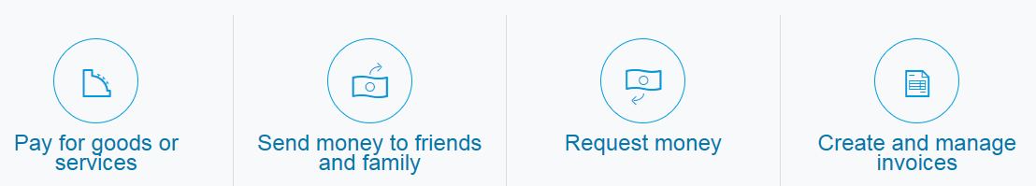
Click Send money to friends and family
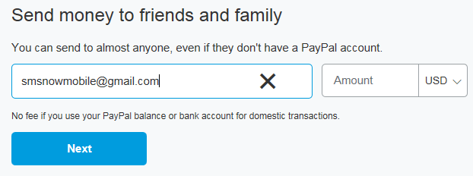Enter Amount you would like to donate. Note there may be additional fees.
Click Next button.
Add a note if you would like to determine how your donation is to be used.
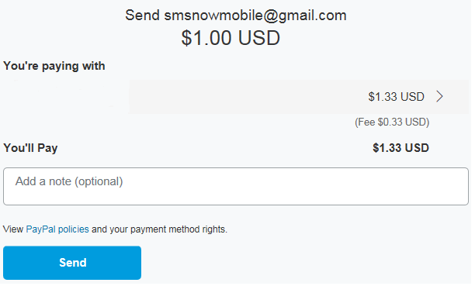
Click Send button.
Thank you for your donations.

